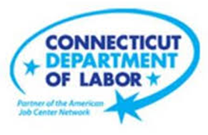

**NEW WEEKLY JOB POSTINGS FROM   
HELP WANTED ONLINE  
Office of Research**

**Week Ending April 29th, 2023:   
Total Ads Stay Flat Over The Week Despite Large Shifts in Manufacturing and Healthcare.**WETHERSFIELD, May 5th, 2023 – During the week ending April 29th, 2023, there were 8,394 new postings, down 16 new ads or 0.2% from a week ago. This last week in April results in that month averaging 8,272 new ads per week. The monthly averages of weekly new ads have experienced five months of continued increases since December 2022, which had a monthly average of 5,818 new ads per week. The table below illustrates this and the larger week-to-week shifts that have occurred during the past two months. When compared to a year ago, April 2023 is up slightly from April 2022, which had a weekly average of 8,118 new ads per week. Across all employers, the largest increase over the week occurred at Hartford Healthcare (+411 new ads) and the largest decrease occurred at Raytheon (-338 new ads). While the state had little change over the week, the U.S. was down 10% or 74,000 new ads as is shown in the graph below.  
  
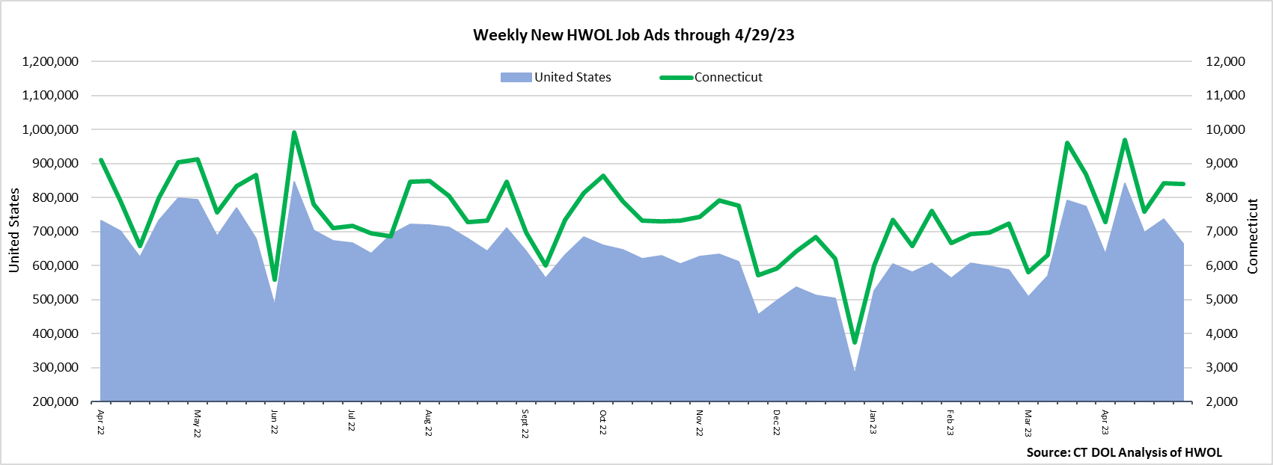  
  
**Industries** with the most new postings include Health Care & Social Assistance, Retail Trade, and Finance & Insurance.

**Occupations** with the most new postings include Registered Nurses, Retail Salespersons, and Personal Service Managers.

**Employers** with the most new postings include Hartford Healthcare, Yale-New Haven Health System, and Trinity Health.

**The three industries with the most new job postings were:**

* **Health Care & Social Assistance** (2,289 new postings, +26% over the week)
* **Retail Trade** (872 new postings, -15% over the week)
* **Finance & Insurance** (723 new postings, -7% over the week)

   
 During the week ending April 29th, 12 industries decreased and 9 increased. The 12 decreasing industries fell by a combined 880 ads. The three largest decreasing industries were Manufacturing (-301 new ads), Retail Trade (-157 new ads), and Educational Services (-148 new ads). Within these three industries, the largest respective employer decreases occurred at Raytheon (-338 new ads), Tractor Supply Company (-41 new ads), and Hartford Public Schools (-25 new ads). The 9 increasing industries grew by a combined 864 new ads, with more than half of that occurring within Healthcare & Social Assistance (+467 new ads). Most of that industry increase occurred at Hartford Healthcare (+411 new ads). Other industries with some of the highest over-the-week increases include Other Services (+97 new ads) and Accommodation & Food Service (+69 new ads).  
  
 For more information on total job ads by industry for Connecticut and its labor market areas, see the monthly report available here: <https://www1.ctdol.state.ct.us/lmi/hwol.asp>

**New Job Postings by Occupation** 

**The occupations with the most new postings were:**

* Registered Nurses ( 706 new postings, +55% over the week)
* Retail Salespersons (231 new postings, -40% over the week)
* Personal Service Managers (229 new postings, +2% over the week)

**Employers with the Most New Job Postings** Employers with the most new job postings during the week ending April 29th were mostly within Health Care & Social Assistance, Retail Trade, and Finance & Insurance. The employers with the most new ads in these three respective industries were Hartford Healthcare (427 new ads), The Home Depot (103 new ads), and Humana (82 new ads). Overall, the 25 employers with the most ads account for a combined 22 percent of total new ads. Among the 25 employers shown above, 17 increased over the week and 8 decreased.   
  
**What is HWOL?**The **Conference Board Help Wanted Online**® Data Series (HWOL) measures the number of new, first-time Online job postings and jobs reposted from the previous month for over 16,000 Internet job boards, corporate boards, and smaller job sites that serve niche markets and smaller geographic areas. To view more HWOL data, go to: <https://www1.ctdol.state.ct.us/lmi/hwol.asp>